AIR QUALITY MONITORING SYSTEM

**OBJECTIVE:**

The aim of this project is to design and develop a portable, low-cost air quality monitoring device using an Arduino microcontroller that can accurately measure and display the Air Quality Index (AQI), temperature, and humidity levels in real time. This device will enable individuals and communities to monitor environmental conditions in their surroundings, providing essential data that promotes awareness of air quality and its potential impact on health and comfort. By providing this accessible monitoring solution.

Key Features:

- Use sensors compatible with Arduino (such as MQ-series gas sensors, PMS5003 for PM, etc.).

- Display readings on an LCD.

This device can be used in homes, offices, or outdoor environments to monitor pollution levels and support informed decisions about air quality management.

**ABSTRACT:**

Air pollution is a critical environmental issue that directly impacts human health, particularly in urban areas where pollutant concentrations can rise to hazardous levels. This project presents the development of a low-cost, portable air quality monitoring device using an Arduino microcontroller. The device is designed to measure key air pollutants, including particulate matter (PM), carbon monoxide (CO), nitrogen dioxide (NO₂), and volatile organic compounds (VOCs), providing real-time monitoring and display of air quality data. Utilizing sensors such as the MQ-series and PMS5003, the device captures pollutant levels, displays the data on an LCD screen, and can optionally store data or transmit it for remote access. Additionally, the device features programmable alert thresholds, allowing users to be notified when pollutant levels exceed safe limits. This project aims to create an accessible solution for individuals and communities to understand better and respond to air quality issues, thereby promoting healthier environments and increasing awareness of air pollution's effects on health.

**INTRODUCTION:**

Air pollution poses serious health risks, particularly in densely populated and industrial areas, where pollutants like particulate matter (PM), carbon monoxide (CO), nitrogen dioxide (NO₂), and volatile organic compounds (VOCs) can reach dangerous levels. However, personal and community access to air quality data remains limited due to the high cost and inaccessibility of large-scale monitoring stations. This project addresses this need by developing a portable, affordable air quality monitoring device using an Arduino microcontroller. Equipped with various sensors, the device measures key pollutants in real time and displays this information on an LCD screen, enabling users to monitor air quality in homes, offices, and outdoor environments. Configurable alert thresholds provide immediate notifications when pollutant levels exceed safe limits, while optional data storage and wireless transmission support long-term tracking and analysis. This device offers an accessible solution to raise awareness and promote healthier environments by empowering individuals to monitor and respond to local air quality conditions.

**HARDWARE REQUIREMENT/DESCRIPTION:**

**Arduino Uno**: The microcontroller that acts as the central processing unit, responsible for receiving and processing data from the air quality sensor, temperature, and humidity sensor, and displaying the information.

**LED or LCD Display:** A display module, such as a 16x2 LCD or OLED display, used to showcase the AQI, temperature, and humidity readings clearly and effectively.

**Air Quality Sensor:** A sensor like the MQ-135 or PMS5003 that measures air quality and particulate matter, providing the necessary data to calculate the AQI.

**Temperature and Humidity Sensor:** A sensor such as the DHT11 or DHT22 that measures ambient temperature and humidity levels.

**Power Supply:** A reliable power source, such as a battery pack (e.g., 9V battery or rechargeable LiPo battery) or USB power adapter, to power the Arduino and other connected components.

**Connecting Wires:** Jumper wires to connect the sensors, display, and Bluetooth module to the Arduino for data transmission.

**Breadboard**: Optional for organizing and testing the circuit connections in a prototype setup.

**Resistors**: If necessary, for specific sensor configurations or pull-up/pull-down purposes.

**CIRCUIT/COMPONENT SPECIFICATIONS:**

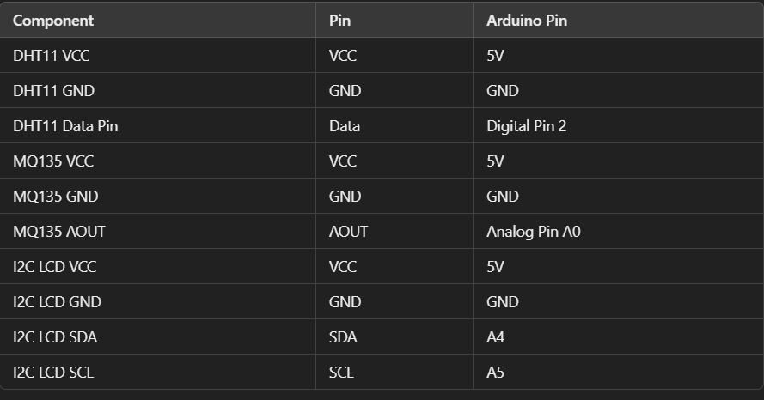

**CIRCUIT DIAGRAM:**

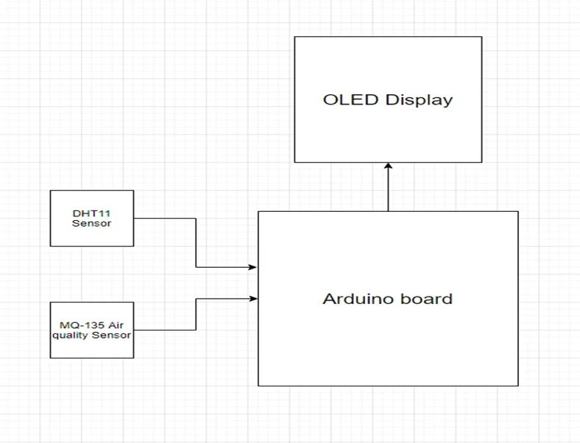

**Figure 1: Block diagram of Air Quality Monitoring System**

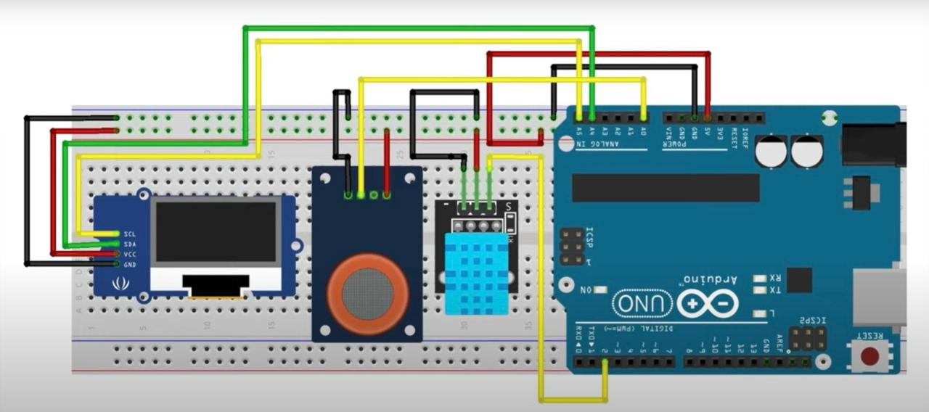

**Figure 2: Circuit diagram of Air Quality Monitoring System**

**PCB DESIGN LAYOUT**

The PCB layout is a critical part of transforming your prototype into a polished mini-project. This section outlines the PCB design considerations and layout details.

1. Component Placement:
   * Arduino: The Arduino board (or a smaller footprint version like the Nano) should be centrally located to minimize the length of sensor connections, reducing potential noise and improving signal integrity.
   * Sensors: The MQ-135, PMS5003, and DHT11 sensors should be positioned to allow unobstructed air flow, ideally on the edge of the PCB or within an opening in the device’s enclosure.
   * Display: Position the LCD display on the front side for easy readability, with supporting circuitry placed on the back side to save space.
2. Signal Routing:
   * Arrange routing to separate analog and digital signals, minimizing interference and ensuring accurate readings from sensors.
   * Use a ground plane to reduce noise, particularly for sensitive analog signals.
3. Power Distribution:
   * Design for both USB and battery power options, with a DC-DC converter if needed for efficient power management.
   * Include decoupling capacitors near each sensor to stabilize the power supply and prevent noise.
4. Testing Points:
   * Add test points for debugging, allowing easy access to voltage readings and signal testing during assembly and troubleshooting.

**FABRICATED PCB ASSEMBLY IMAGE AND OUTPUT MEASUREMENT**

1. PCB Assembly:
   * The assembled PCB should include all components securely soldered, with headers for the sensors, display, and any additional modules (like a Bluetooth module, if applicable).
   * Assembly Image: Include a clear image of the fabricated PCB with annotations pointing out key components like the Arduino, sensors, and power connections. Ensure the image highlights the PCB’s compact, organized layout.
2. Output Measurement:
   * AQI Readings: After powering up the device, place it in various environments (e.g., indoor, outdoor, near a traffic area) to observe AQI readings. Record the output data displayed on the LCD and cross-reference it with nearby air quality data sources to assess accuracy.
   * Temperature and Humidity Readings: Verify these measurements by comparing them with readings from a reliable weather station or device in the same environment.
   * Alert Thresholds: Test the alert functionality by exposing the device to higher concentrations of pollutants (e.g., near a lit incense stick or small smoke source). Ensure the device correctly triggers alerts when pollutant levels exceed preset thresholds.

**DESIGN FORMULA/ CONSTRAINTS:**

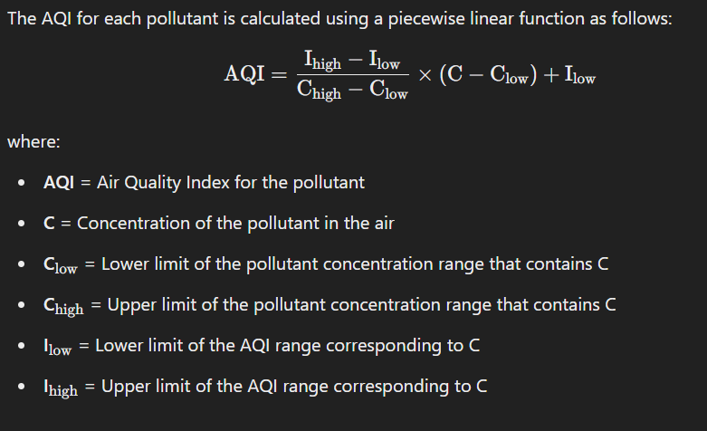

**DESIGN ISSUES:**

Designing a portable air quality monitoring device using an Arduino microcontroller presents several challenges that must be addressed to ensure functionality and user satisfaction. Key issues include ensuring accurate sensor calibration for reliable data, managing power consumption for extended battery life, and creating an intuitive user interface for clear data display. Wireless communication, particularly if using Bluetooth, raises concerns about range, interference, and data integrity, while the device must be robust enough to function in varying environmental conditions. Balancing size and portability with the need for effective sensors and power sources poses further challenges, as does the consideration of costs without sacrificing quality. Additionally, efficient data storage and processing, along with the implementation of user notifications for high AQI levels, require careful planning and coding to ensure reliability. Rigorous testing and validation of the device's performance in real-world conditions are essential to meet user expectations and ensure accurate monitoring. Addressing these design issues will lead to a more robust and user-friendly air quality monitoring solution.

**APPROACH / METHODOLOGY:**

The methodology for developing a portable air quality monitoring device using an Arduino microcontroller begins with a literature review to understand existing technologies and select appropriate components, including an air quality sensor (like PMS5003 or MQ-135), temperature and humidity sensor (DHT11 or DHT22), and a display module (such as a 16x2 LCD). Following component selection, a circuit design is created, and a prototype is assembled on a breadboard, ensuring proper connections. The Arduino is then programmed to read data from the sensors, calculate the Air Quality Index (AQI), and display real-time information while implementing alert mechanisms for high pollutant levels. Calibration and initial testing are conducted in controlled environments, followed by validation of readings against reference data. Once the prototype is functioning correctly, the final assembly involves designing an enclosure for portability and protection. Field testing is carried out to assess performance under various conditions, and data is analyzed to ensure accuracy. User feedback is collected for potential improvements, leading to final adjustments before deployment. This organized approach facilitates the development of a reliable and effective air quality monitoring solution.

|  |  |
| --- | --- |

**RESULTS:**

|  |  |
| --- | --- |
| **Message Display Duration (seconds)** | **Delay Time (milliseconds)** |
| 5 | 5000 |
| 10 | 10000 |
| 15 | 15000 |
| 20 | 20000 |
| 30 | 30000 |

**CONCLUSIONS:**

In conclusion, the development of a portable air quality monitoring device using an Arduino microcontroller represents a significant advancement in accessible environmental monitoring technology. By integrating key sensors for measuring air quality, temperature, and humidity, the device provides real-time data that empowers individuals and communities to understand and respond to air quality issues. The systematic methodology encompassing component selection, circuit design, programming, calibration, and testing ensures the device is both reliable and user-friendly. Furthermore, the incorporation of features such as alert mechanisms for high pollutant levels enhances its practicality and responsiveness to health risks. As air quality continues to be a pressing global concern, this device not only facilitates informed decision-making but also promotes greater awareness and action towards improving air quality in various environments. The project sets the groundwork for future enhancements, including the potential integration of additional sensors and wireless communication capabilities, further expanding its functionality and impact.

**REFERENCES:**

1)**Books**:

* Monk, S. (2016). Programming Arduino: Getting Started with Sketches. McGraw-Hill Education.
* Margolis, M. (2011). Arduino Cookbook. O'Reilly Media.

2)**Websites**:

* Arduino Official Documentation: https://www.arduino.cc/en/Reference/HomePage
* HC-05 Bluetooth Module Guide: https://www.electronicwings.com/nrf/hc-05-bluetooth-module
* LCD with Arduino Tutorial: https://www.arduino.cc/en/Tutorial/LibraryExamples/LiquidCrystal

**APPENDIX:**

**LCDI2c:**

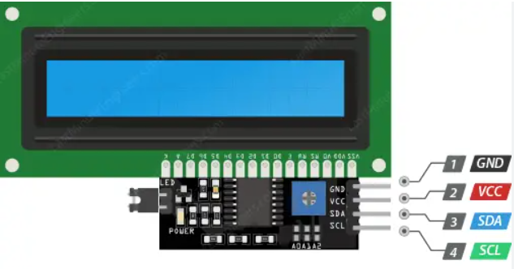

An LCD I2C module allows easy communication with an LCD display using only two wires (SDA and SCL) via the I2C protocol, reducing pin usage. It's popular in microcontroller projects for efficient text display integration.

**Resistor:**

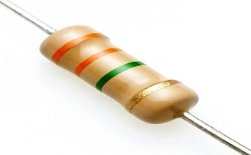

A **resistor** is a passive electronic component that limits current flow in a circuit and divides voltages. Available in fixed and variable types, resistors are crucial for controlling the behavior of circuits and setting operating conditions for other components.

**MQ135**:

The MQ-135 Gas sensor can detect gases like Ammonia (NH3), sulfur (S), Benzene (C6H6), CO2, and other harmful gases and smoke. Similar to other MQ series gas sensor, this sensor also has a digital and analog output pin. Whn the level of these gases go beyond a threshold limit in the air the digital pin goes high

.

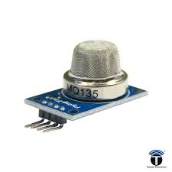

**DHT 11 SENSOR**

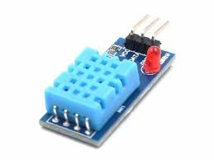

The DHT11 is a digital temperature and humidity sensor that is often used in projects for hobbyists and beginners. It is a low-cost, basic sensor that is easy to use and can be used in a variety of applications.